Intelligent Appointment Management
Intelligent Appointment Management 1
Executive Summary 1
Introduction 1
Intelligent Appointment Management 1
A Solution for Scheduling Challenges 2
Core Capabilities 2
Manage Patient Appointments 7
Intelligent Appointment Management Setup 7
IAM Implementation Process 7
Appointment Scheduling 8

Executive Summary
Intelligent Appointment Management (IAM) for Salesforce Health Cloud centralises appointment scheduling in a single console, bringing together real-time availability from Salesforce Scheduler, electronic health record (EHR) scheduling engines, or both. It simplifies fragmented scheduling processes and helps patients and appointment schedulers find suitable providers, appointment times and locations. The intended benefits include a better patient experience, improved first-call resolution, reduced administrative complexity and fewer missed appointments.
Core capabilities include staff-assisted booking and patient self-scheduling, configurable visit types and pre-visit requirements, Flow-based appointment guidance, and visibility of assigned and previously seen providers. A consolidated appointment list and configurable statuses support ongoing management, while CRM Analytics enables attendance monitoring. Automated reminders and predictive appointment recommendations can help reduce no-shows; CRM Analytics Predictions requires separate setup and is not preconfigured with IAM.
Implementation requires appropriate user permissions, Provider Search configuration, provider and specialty data, visit types, appointment reasons, engagement channels and status values. Organisations must configure Salesforce Scheduler or connect external scheduling systems, including identifier mappings between Health Cloud and external records, and make the scheduling console available on patient records. Together, these foundations support a connected appointment workflow that improves access to care and gives organisations greater visibility of appointment operations.

Introduction
Often, appointment scheduling is the very first interaction new patients have with a health practitioner. If it’s a bad experience, they may not want to come back, or they may not even show up for their appointment. This document attempts to explain the benefits of Intelligent Appointment Management and describe the capabilities of it.

Intelligent Appointment Management
Intelligent Appointment Management for Health Cloud maximizes appointment scheduling efficiency by centralizing the process in a single, flexible, intuitive, and intelligent console. The console, which is the user interface (UI), is powered by scheduling engines behind the scenes. These engines can be Salesforce Scheduler or Electronic Health Record (EHR) scheduling engines, or both. IAM aggregates multiple scheduling engines so that schedulers and patients can see all available appointments in one place. The result is an enhanced scheduler and patient experience.
IAM makes it easy for patients to connect with care providers at the time and location that suits them. Appointment schedulers—that is, care coordinators and call center representatives—can view the real-time availability of patients’ providers and thus manage scheduled and walk-in appointments.

A Solution for Scheduling Challenges
IAM helps healthcare and life science organizations solve many of the challenges that come with scheduling and managing appointments. Here are examples of how businesses benefit from having IAM.
- Streamlines complexity and inefficiency: Because its UI is powered by multiple scheduling engines, IAM reduces the need to check appointment availability across multiple systems.
- Improves appointment attendance: Automated appointment reminders help reduce appointment no-shows. Predictive analytics features help schedulers suggest appointment times for which the patient is most likely to show up.
- Helps schedulers and patients identify the right care: With a guided branching logic powered by Flow, schedulers and patients find the right type of appointment for their needs.

Core Capabilities
Schedule appointments for patients: The centralized scheduling of IAM helps appointment schedulers improve first-call resolution and reduce no-shows. The Salesforce admin can configure the Appointment Management console to make it easily available on the patient’s account page layout.
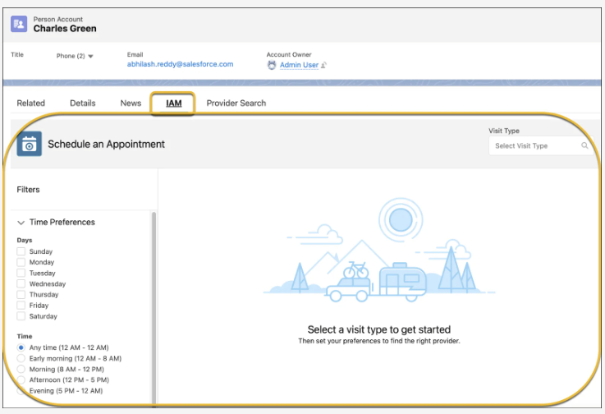
Schedule your own appointments: Many patients and health plan members prefer the control and convenience of booking their appointments online rather than using a call center. With IAM, patients can easily self-schedule their appointments as guests. They don’t need to provide any information that is not critical for scheduling the appointment, which saves them time. IAM matches their appointment with their record in Salesforce. If they are new patients, Salesforce creates a new patient record automatically. When they come to their first appointment, the patient supplies all the information that the provider needs.

To find their ideal appointment, patients can use filters, such as engagement type (video, phone, in-person), languages spoken, and gender.
Use an electronic health record system: The data that supports patient appointment booking, such as provider availability, is often stored in an EHR system. The Salesforce admin can integrate the EHR system with Health Cloud and use the data. You can pull in available appointments from the EHR system, do the scheduling in Salesforce, and then push the data back to the EHR system. Alternatively, you can use Salesforce Scheduler as the backend scheduling engine.
Select visit types and pre-visit requirements: Based on the reason for the visit, the appointment scheduler can simply select the most suitable option from a set of visit types, such as dental, physiotherapy, or follow-up.
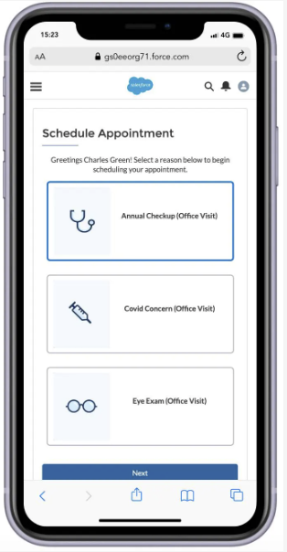 | 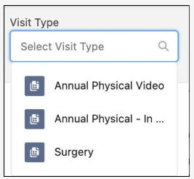

If a visit type has prerequisites, then the application shows them when the visit type is selected. For example, it can show ‘Get the latest blood reports’ as a prerequisite for a follow-up visit.
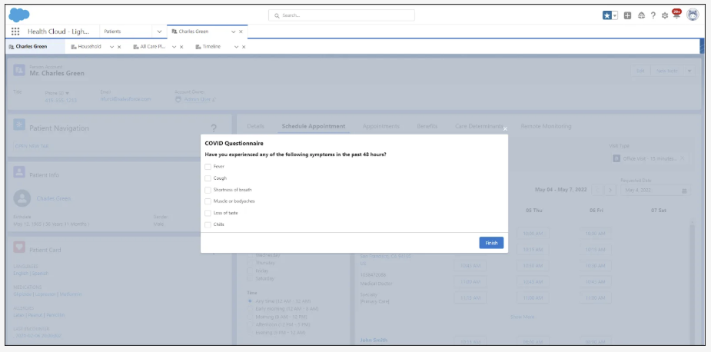
The admin can configure visit types based on the organization's requirements.
Recommend appointments: Appointment guidance takes the guesswork out of scheduling appointments. With Flow, administrators can easily integrate guided steps into the appointment scheduling console to recommend the most appropriate appointment type, practitioner, and more. This helps call center representatives quickly find the right appointment for patients.
View assigned and past providers and their availability: When an appointment scheduler selects a visit type, IAM returns relevant providers and their available appointment slots in real-time. No more toggling back and forth between multiple scheduling systems.
If a patient has an assigned or primary care provider, IAM shows a special badge on the patient’s card and the provider’s card, using data that the Salesforce admin sets up in Health Cloud. If the patient has received care from a provider in the past, then the cards also show the past provider badges. The default sort order of the providers places the assigned and past providers at the top of the results list. The Salesforce admin can also associate healthcare practitioner records with specific facilities, which show up along with the provider information on the patient’s card.
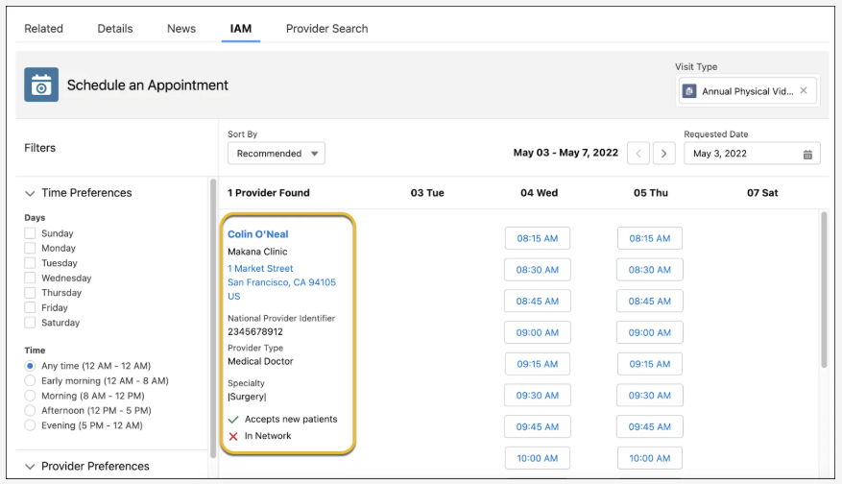
View a patient’s appointments: The application shows a list of all the appointments for a patient on a single page. The Salesforce admin can customize the page title and columns when setting up Intelligent Appointment Management.
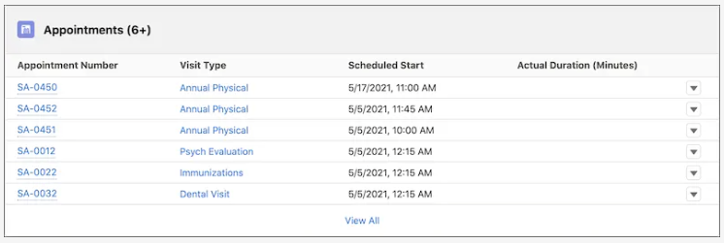
Patients and appointment schedulers can track the status of an appointment with customized statuses and status categories using data that the Salesforce admin sets up in Health Cloud. Every appointment record shows the status details.
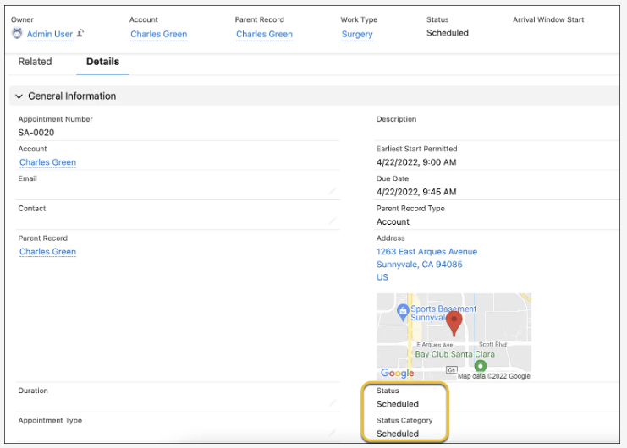
Reduce no-shows using CRM Analytics Predictions: When appointment schedulers select a visit type, they see a list of suggested days and times that a patient is most likely to attend an appointment. This helps the schedulers select the recommended slot, reduce the probability of patient no-shows, and prevent costly leakage. The Salesforce admin must set up CRM Analytics Predictions to enable this capability. CRM Analytics Predictions is not preconfigured with Intelligent Appointment Management.
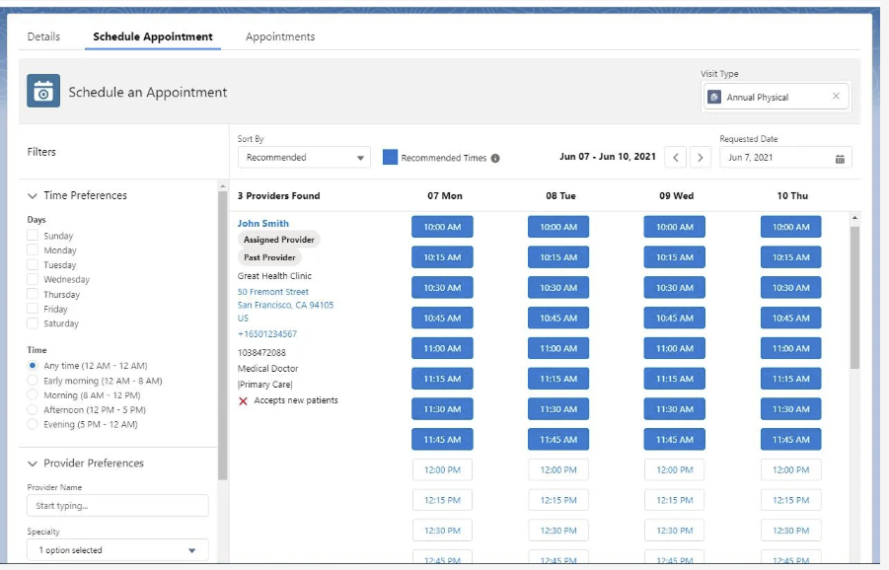
Monitor and manage appointment operations: With CRM Analytics, organizations can monitor their appointment attendance and observe trends. They can create their own, customized dashboards, or use a pre-configured one.

Manage Patient Appointments

Intelligent Appointment Management Setup
There are several tasks that staff perform before setting an appointment. Let’s explore what the process looks like and how the steps impact the implementation outcomes.
Task | Why
Assign permissions. | You likely want to restrict the number of people who can use IAM and schedule appointments. So, create profiles for users that will use IAM, then create user records, and assign permission sets.
Set up Provider Search. | IAM uses the Provider Search feature in Health Cloud to perform the search function.
Configure visit types. | Visit types help appointment schedulers look up providers based on the reason for the visit (dental, physiotherapy, follow-up, and so on), and view appointment availability.
Record provider NPIs. | National Provider Identifier or NPI is assigned to every facility and licensed practitioner in the United States. It helps refine the search.
Create care specialties. Then associate practitioners and visit types with their care specialties. | Patients seek appointments with a doctor with a particular specialty. IAM sorts providers to show only appointment slots for the specialty that the patient requested.

IAM Implementation Process
To implement IAM, you need to complete the following tasks.
Task | Why
Create work type code set bundles. | Code sets and code set bundles standardize definitions and concepts in healthcare. When you set up IAM, work type code set bundles map visit types to code set bundles, which describe the work in the scheduling system.
Configure appointment status values. | Enable users to track the status of their appointments with customized statuses and status categories.
Create appointment reasons. | Give appointment schedulers and patients a set of easy-to-understand options to pick from when selecting the reason for booking an appointment.
Create engagement channel types. | Engagement channel types define the ways in which a provider is available, such as in person or by phone.
Indicate prior care. | Enable appointment schedulers to book an appointment for the patient with doctors or care providers they have a history with.
Set up Salesforce Scheduler for Intelligent Appointment Management or link Intelligent Appointment Management to external scheduling systems. | Use Salesforce Scheduler or an external scheduling system as the engine to power your appointment workflows. To schedule appointments using an external system, first set up identifier records. Identifier records map records in Health Cloud to corresponding records in an external system that has scheduling, such as an EHR system.
Add the Healthcare Appointment Scheduler component to the account page layout. | Ensure the Intelligent Appointment Management console is easily available to appointment schedulers as a tab on the patient record page.
Set up CRM Analytics Predictions. | With CRM Analytics Predictions, IAM highlights suitable visit times for the patient based on their prior visits.

Appointment Scheduling
rom the account record page, she selects a tab to open the IAM console. Staff can then select an appropriate visit type.
By default, the resulting providers are sorted by recommended providers, with the assigned providers at the top, past providers next, and new providers last. For a new patient, only new providers appear.
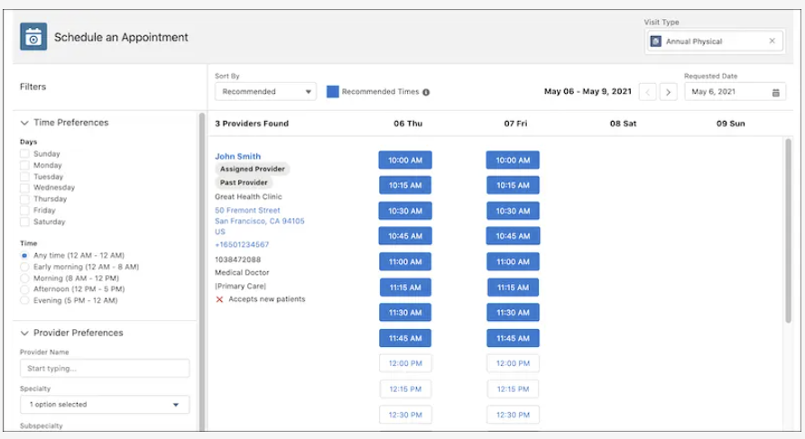
By default, the console shows providers within five miles of the patient’s mailing address. In the New Appointment window, staff reviews the appointment details, adds extra details about the appointment in the Comments field, and saves the appointment.
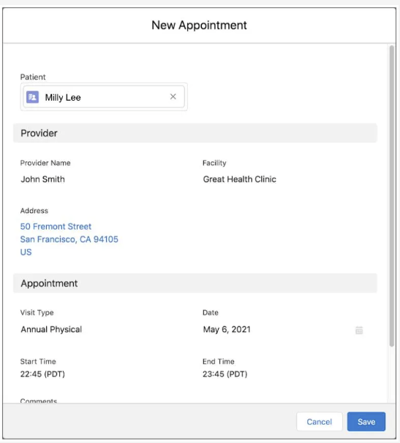
The new appointment is added to the Appointments list.


